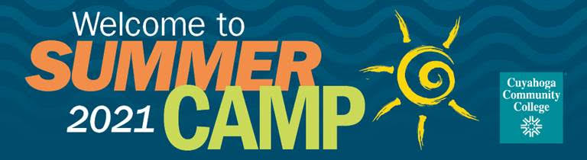

As COVID-19 continues to impact our community, the health and safety of our campers, instructors and staff is our utmost priority. Therefore, a variety of virtual and in-person camps will be offered in 2021.

Mad Science® camps will take place on-site, giving kids the opportunity to explore engineering using LEGO® bricks, convert substances via chemical reactions, learn about outer space or build robots. Our culinary camp will teach campers the basics of food safety and proper handling of utensils in our state-of-the-art kitchen at Corporate College® East. Virtual Black Rocket camp options will focus on coding, designing and programming.

Nuts and Bolts Academy camps allow youth to use state-of-the-art manufacturing equipment to design and create objects born in their imagination. Virtual and hybrid programs are available.

Tri-C’s Creative Arts Academy will once again offer summer camps for children ages 3-18, including dance academy, vocal arts mastery, orchestra and JazzFest academy.

Summer camps may be eligible for remission of fees as outlined in the College’s policies and procedures.

View all available camps and register at tri-c.edu/summercamps.

